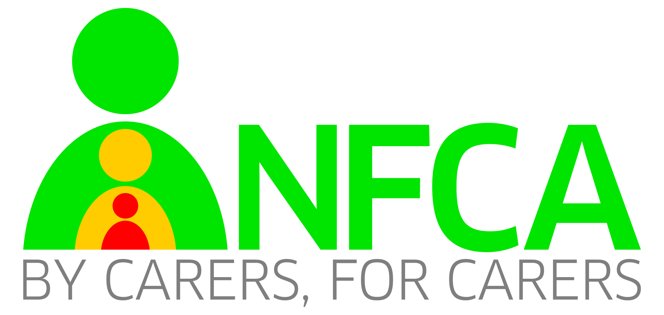

Support Groups in Northamptonshire

We have 7 support groups. Some are facilitated by Supervising Social Workers, some are run by Foster Carers. We wish to formalise the structure of these and take over the running of them. They will be run by carers, for carers.

The structure will be that there are 2/3 Lead Foster Carers for each group. There will also be an assigned SSW for each group.

Role of the Lead Foster Carer

Book the room to meet, arrange for the bill to go to NCC.

Provide refreshments and collect contributions from members.

Liaise with SSW about attendance.

Feedback to NFCA meetings

Feedback to SSW any issues that need raising by them

Provide contact details for Share the Care and NFCA dates email.

Role of SSW

Liaise about attendance at meetings- depending on groups wishes. Attend meetings quarterly for between 30 mins and 1 hour.

Help to book speakers that the group would like.

General

We would also like new carers to be signposted to their nearest group by their SSW.

All carers can attend any (or all) groups

If a group books a speaker they can be publicised to all members to encourage good attendance.