

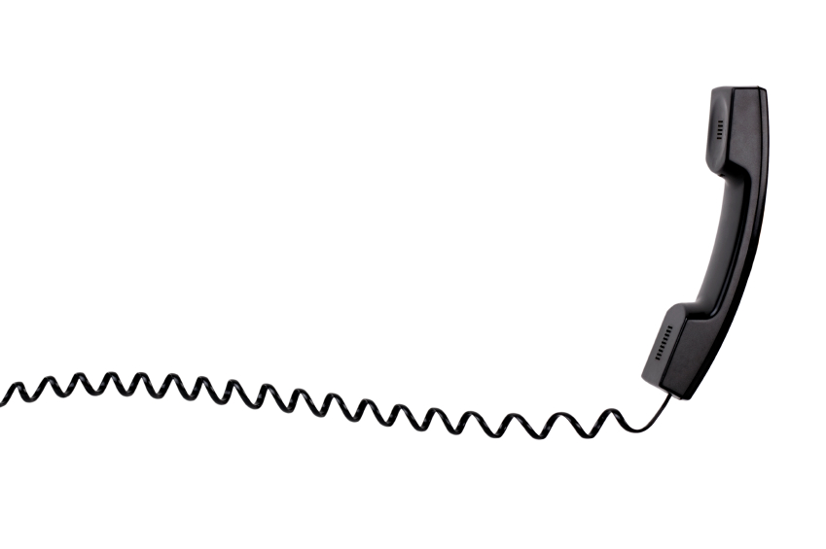

**Duty Line for Looked-after Children’s Mental Health Team**

**Hours: Monday-Friday 9.30 a.m. – 4.00 p.m.**

**Telephone number: 03000 270550**

[**lac.duty@nhft.nhs.uk**](mailto:lac.duty@nhft.nhs.uk)

**What is the Duty Line for?**

The LAC Duty Line allows professionals to contact the LAC Mental Health Team for:

* + Urgent or crisis situations for looked-after children
  + Concerns about risk of harm to self or others
  + Children or young people in emotional crisis
  + When carers are finding it difficult to cope
  + When placements are at risk of breakdown

**What can I expect from the Duty Line?**

* A LAC Administrator will take your call. Please be prepared to answer a list of questions about the young person and the current situation. This will enable the admin and clinical team to gather sufficient information to respond to your call
* The information taken by the administrator will be passed to the on duty clinician, who will respond before the end of the working day (for calls received after 3pm, the duty clinician may contact you the following day)
* A senior clinician from the LAC Mental Health Team will receive the information given in the duty call and contact you to discuss the situation. They will aim to offer advice and guidance, and where required, establish a plan with you about how to manage the crisis situation.

What the Duty Line is **not** for

* General or routine enquiries, e.g. appointment times or group attendance.
* Urgent queries about children who are **not** looked-after.

**For out of hours support:**

Mental Health Hub: 0800 448 0828, CAMHS Live (Child and Adolescent Mental Health Service) 0800 170 7055 (option 1, option 1), https://www.nhft.nhs.uk/camhslive or via the out of hours GP services.